Ideation Phase
Define the Problem Statements

Date | 19 February 2026
Team ID | LTVIP2026TMIDS82248
Project Name | DocSpot: Seamless Appointment Booking for Health
Maximum Marks | 2 Marks

Problem Statement -1:
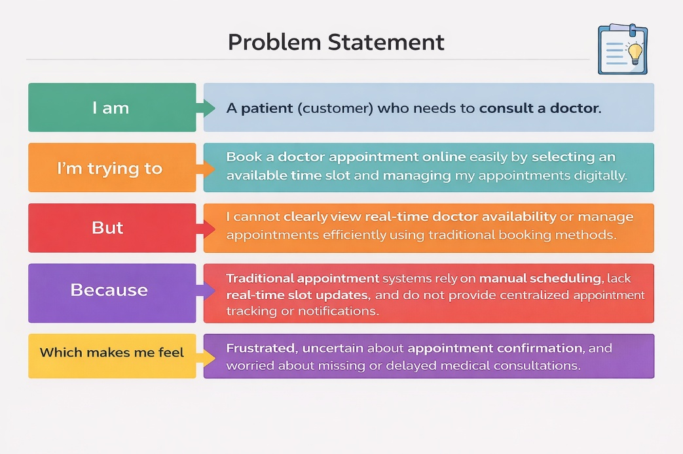
Problem Statement -2:
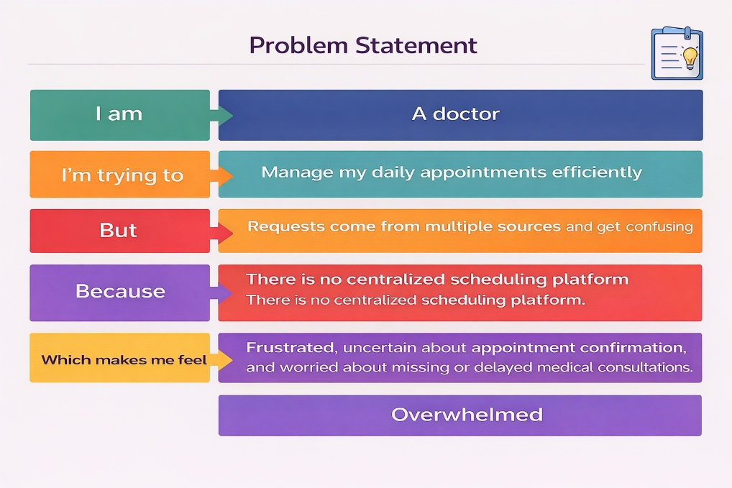

Problem Statement (PS) | I am | I’m trying to | But | Because | Which makes me feel
PS-1 (Patient Perspective) | A patient who needs medical consultation. | Book a doctor appointment online easily by selecting an available time slot. | I cannot clearly view real-time doctor availability or appointment status. | Traditional booking methods do not provide updated slot availability or digital tracking. | Anxious, uncertain, and frustrated about appointment confirmation.
PS-1 (Patient Perspective) | A doctor managing multiple patient consultations. | Manage and organize my daily appointments efficiently. | Appointment requests arrive from multiple sources and become difficult to track. | There is no centralized appointment scheduling and management platform. | Overwhelmed and stressed while handling appointments.

